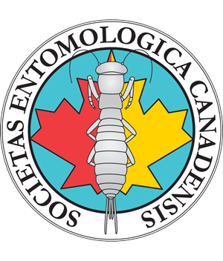
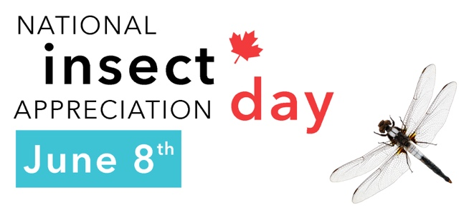

On June 8th, we invite you to celebrate National Insect Appreciation Day (NAIAD) with thousands of insect enthusiasts, amateurs, and professionals all across Canada. This year, the in-person activities scheduled for NAIAD were canceled because of the COVID-19 pandemic. However, it will still be possible to participate in the “insect picture challenge” on social media. We hope that this challenge will prompt the public to develop their curiosity towards insects and raise awareness about the presence of insects all around us.

In order to participate in the challenge, a person will have to post a least one picture of an insect during the National Insect Appreciation Day on June 8th. When posting the photo, the participant should include associated hashtags and nominate five friends by inviting them to also post an insect picture.
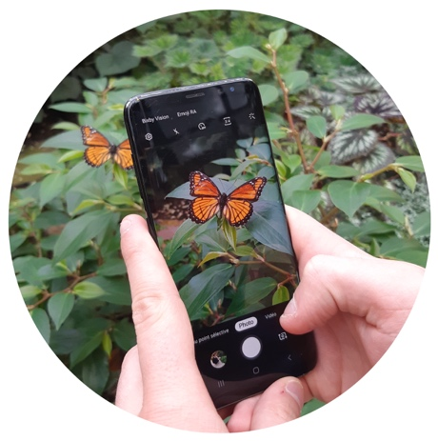
Hashtags :

#InsectPictureChallenge
#NationalinsectDay

How a hashtag works :

A hashtag makes it possible for other users to easily find messages and post with a specific theme or content. Simply use the hashtag on social media (Facebook, Instagram or Twitter) and make sure that your photograph is public.

Examples of posts:

- Announcement of the challenge (before June 8)

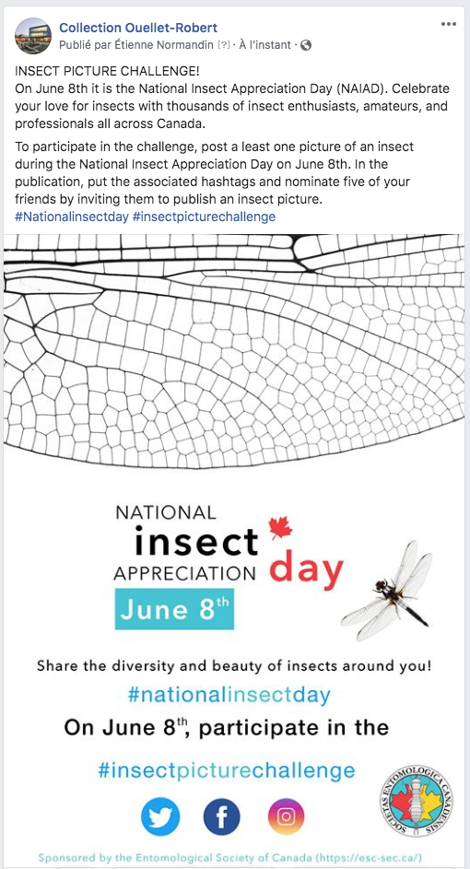

- Post announcing the challenge (June 8)

