JFJun0619
2019 June 6

In case you didn’t spot the cocoon of Behrensia conchiformis yesterday, here it is.

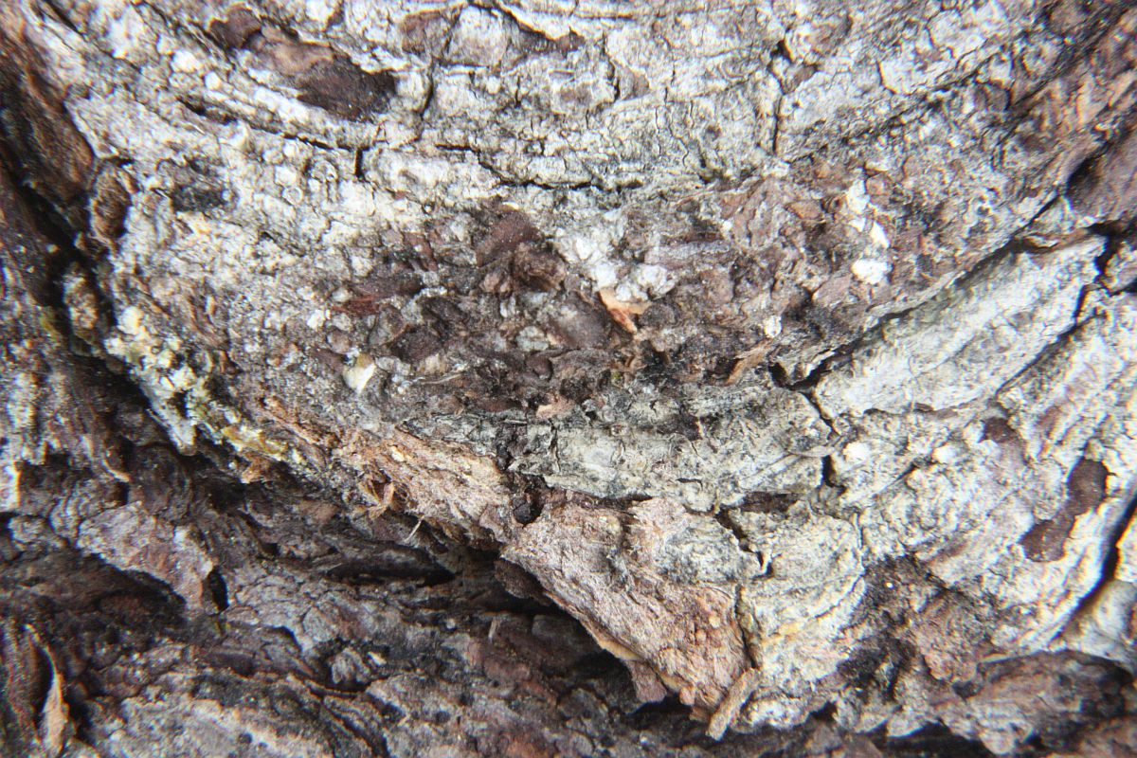
Behrensia conchiformis (Lep.: Noctuidae) Jeremy Tatum
See it now?

